

Student name: noor aldeen faris jada

Student number:12116090

Submitted to: D. Mahmoud Sharaf

Title name:
Loop Unrolling

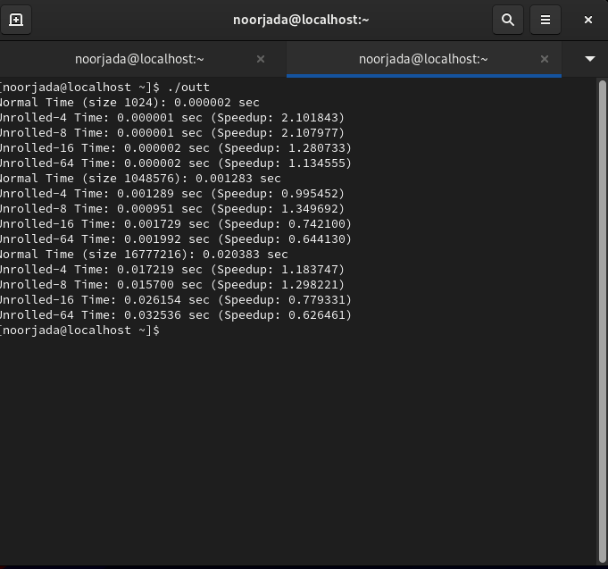

Tables Format

 |  | Unrolling Time
Input-size | Normal | Degree-4 | Degree-8 | Degree-16 | Degree-64
1024 | 0.000002 s | 0.000001 s | 0.000001 s | 0.000002 s | 0.000002s
1024*1024 | 0.001283 s | 0.001289 s | 0.000951 s | 0.001729 s | 0.001992 s
16*1024*1024 | 0.20383 s | 0.017219 s | 0.015700 s | 0.026154 s | 0.032536 s

 |  | Unrolling Speedup
Input-size | Normal | Degree-4 | Degree-8 | Degree-16 | Degree-64
1024 |  | 2.101843 | 2.107977 | 1.280733 | 1.134555
1024*1024 |  | 0.995452 | 1.349692 | 0.742100 | 0.644130
16*1024*1024 |  | 1.183747 | 1.298221 | 0.779331 | 0.626461

